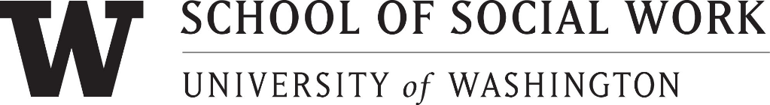

NOMINATION FORM

The Mary Grembowski Staff Recognition Award
_____________________________________________________________________

Please complete this form and submit with your letter of nomination:

Nominee:
Unit/Office:

Job Title/Responsibility:

Supervisor’s Name:

Others to be contacted in support of this nomination (please provide email address/contact information if individual to be contacted is outside of SSW):

Nominator’s Name:

Please check if: _____ Faculty

_____ Staff

_____ Student: Undergraduate _____
MSW Program _____
Ph.D. Program _____
Unit/Office:

Phone:

Signature of Nominator: _____
DEADLINE FOR SUBMISSION: Friday, May 28, 2020

FORMS AND LETTERS ARE DUE NO LATER THAN
Friday, May 28, 2020.

SUBMIT TO: The Mary Grembowski Staff Recognition Award Selection Committee
c/o Vicki Anderson-Ellis (if mailing from off-campus: University of Washington, School of Social Work, 4101 15th Ave. N.E., Seattle, WA 98105
The winner will be announced at the Annual Faculty/Staff meeting and recognition event in early June

GUIDELINES
The Mary Grembowski SSW Staff Recognition Award honors one outstanding individual that works in the School of Social Work who exemplifies both the values of the School as well as values of outstanding service as an employee. The successful nominee needs to demonstrate one or more School of Social Work traits:
- Commitment to social works and its mission
- Promotes social & economic justice for poor and oppressed populations
- Enhances the quality of life for all
- Values education, research, and service as a vehicle to challenge injustice to provide a more humane society that focuses on the health and well-being of all populations served
- Extraordinary and meritorious performance in representing the School of Social Work to faculty, students, staff and outside groups and organizations - examples:
  - Represents the School in the best and most positive light to faculty, staff, students, general public, etc.
  - Performance above and beyond normal course of job duties and responsibilities
  - Patience, understanding in dealing with students, colleagues and people in the community; good judgment, positive attitude, professionalism, etc.
- A commitment to positive working relations with the School of Social Work Community must be evident
- Positive attitude and cooperation with one's colleagues must be demonstrated
- Service to School (i.e., participation in School related activities not included within job description); or service to University or the larger community
In addition, the successful nominee needs to exhibit the following UW traits:
- Provides superior sustained service or a special one-time contribution to the mission of the unit or University;
- Continually contributes to a respectful, diverse, and collaborative work environment;
- Exhibits exceptional resourcefulness, innovation, or creativity, and exemplifies excellence and integrity in workplace relationships, interactions, and decision-making
If there is an employee at the School that fits these qualifications, it is highly encouraged that nominations are submitted to honor the work they do publicly.
Eligibility
The Mary Grembowski Staff Recognition Award requires the following employee status to be eligible for nomination:
- Employed continuously by a School of Social Work unit for at least six months (prior to January 1, 2020)
- Must be at least 50% time
- Open only to Classified and Professional Staff
- Must demonstrate at least 1 trait from both School of Social Work and UW criteria
Nomination
The Mary Grembowski Staff Recognition Award requires the following information for consideration of the award:
- Nomination Form
- 1 letter (not to exceed 600 words) outlining the reason and case for the nomination
- 2 references (e-mails and/or phone numbers) that the committee can contact for additional information and verification of criteria
For further information, please contact sswhr@uw.edu.

